UID exp-07

Rollno:240701529
AIM:
The aim is to trial different app layouts and color schemes and evaluate user feedback on aesthetics and usability using GIMP.

PROCEDURE:
Step 1: Install GIMP
- Download and install from the official website.

Step 2: Create a New Project
- Open GIMP
- Canvas Size: 1080 × 1920 pixels (standard mobile screen)

Step 3: Base Layout Design
- Divide Sections:
  - Use Rectangle Select Tool to define Header, Content Area, and Footer.
  - Fill using Bucket Fill Tool with base colors.

Add UI Elements:
  - Text Tool: For headings, button texts, and labels.
  - Shape Tools: For buttons, input fields, image placeholders.

Layer Organization:
  - Assign each UI component to a separate named layer:
    - Example: Header, Button Login, Text Title, Input Field Email

Step 4: Create Colour Variants
- Duplicate Layouts:
  - Right-click on the project tab > Duplicate.
    - Edit each with different colour schemes using Colorize Tool or Bucket Fill.

Save Layouts:
  - File > Export As:
- Layout1.png
- Layout2.png
- Layout3.png

Step 5: Collecting User Feedback Google Form Link:
https://forms.gle/sxuuHVgaTmMWeRKv6

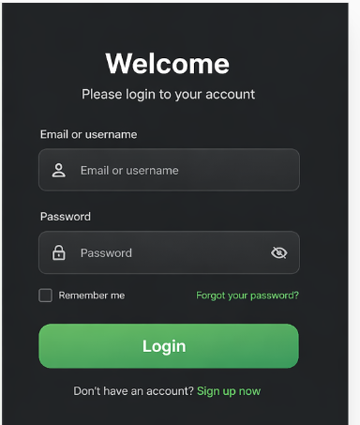
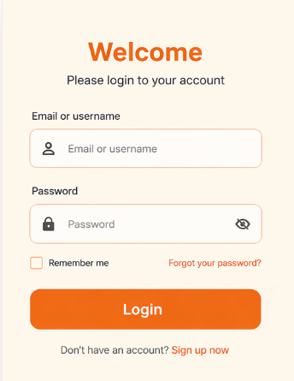
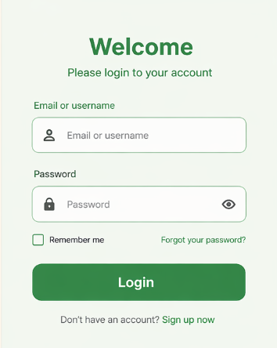

Procedure:
- Shared all three layout images with users.
- Asked users to rate based on:
  - Visual appeal
  - Usability
  - Readability
  - Colour preference

User Feedback:
Layout 1:
- Simple layout with bold header and minimal UI •
Improve colour contrast
- Add button styling (e.g., shadow or depth)

Layout 2:
- Improved hierarchy with vibrant colour palette
- Slightly cluttered background, tight spacing
- Increase spacing between sections

Layout 3:
- Clean, minimal, professional layout with consistent spacing •
Keep design as-is

- Possibly apply theme customization options in final product

Final Recommendation
Preferred Layout: Layout 3 Why?
- Clean and modern look
- Excellent usability
- Balanced colour scheme
- High user satisfaction in both function and form

Step 6: Iterate and Refine
- Refine the Design:
  - Based on the feedback, make necessary adjustments to the layout and color scheme. •

Experiment with additional variations if needed.
- Final Testing:
  - Conduct a final round of testing with the refined design to ensure usability and aesthetic satisfaction.

